Ideation stage: Brainstorming ideas
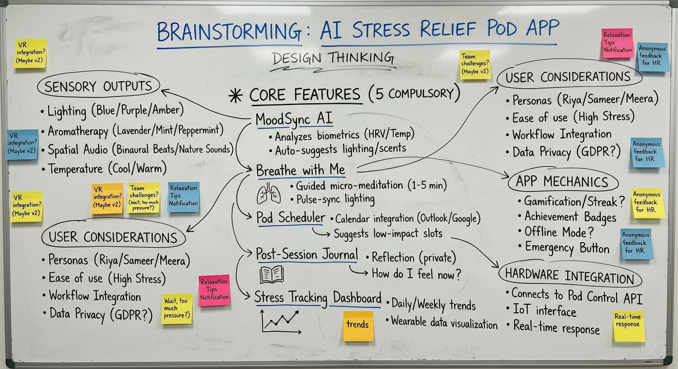

Final brainstorming findings:
- MoodSync AI: A core engine that processes biometric data (HRV, heart rate) and voice tone to automatically adjust pod settings like lighting and aroma.
- Breathe with Me: An interactive module offering guided micro-meditation (1–5 mins) that uses rhythmic light pulses to help users sync their breathing.
- Pod Scheduler: A smart booking system that integrates with office calendars (Google/Outlook) to find low-stress gaps in a user's workday.
- Post-Session Journal: A private digital space for users to record their mood and physical relief after a session, helping the AI learn their preferences.
- Stress Tracking Dashboard: A visual interface showing real-time stress levels, historical trends, and progress badges to encourage wellness habits.

